COMMUNITY SERVICES ADVISORY COMMISSION REPORT
Redding Convention & Visitors Bureau (RCVB)
January 2019

Tracking Transient Occupancy Tax (TOT)
TOT revenue reported in January for the City of Redding and collected from Redding lodging properties was $523,388.46, which is a 67.1 percent increase over January of 2018. Overall, this is a fiscal year-to-date TOT increase of 30.3 percent.
Turtle Bay Numbers
Turtle Bay Visitor Desk – year-to-year comparison for Visitor Statistics:
 | January – 2018 |  | January – 2019
Directions | 44 |  | 19
RV Info | 1 |  | 0
Hotel Info | 4 |  | 4
Marina/Camping | 0 |  | 3
Food | 6 |  | 20
Shopping | 0 |  | 31
Activities/Maps | 106 |  | 205
Total Visitor Requests | 161 |  | 282

Marketing and Advertising:
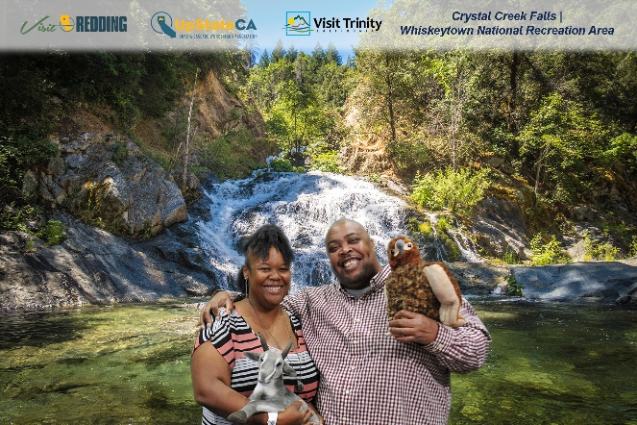
- The Redding CVB presented the Redding area to potential visitors at the San Diego Travel and Adventure Show. The show had 15,311 attendees, and the Redding booth distributed 401 Redding Visitor Guides, 426 Redding Trail Maps, and received 306 new subscribers to the Visit Redding e-newsletter. Redding sponsored the official Travel and Adventure Show photo booth where 582 people walked away with a total of 303 photos that helped them visualize what it would be like to be at one of the Redding area attractions.
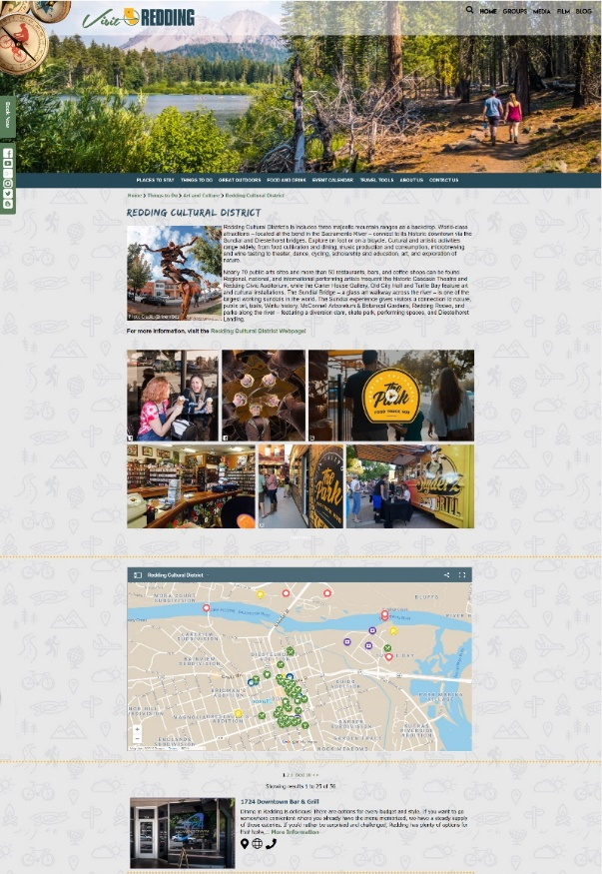
- The Redding CVB partnered with the Shasta-Cascade Wonderland Association to place a full-page ad in Visit California’s 2019 California Visitor’s Guide with a circulation of 500,000 copies distributed both domestically and internationally. The publication also allows for readers to make direct requests back to the Redding CVB for more information on our area. Each year the partners in the ad get about 300 leads for a total of about 3,600 leads total.
- A reskin of VisitRedding.com was worked on throughout the month of January in order to create an interface that offers a slick modern look with additional functionality that expands the variety of features including image galleries, interactive maps, virtual tours, and new video options. The new site is going through final tests and is planned to go live within the first two weeks of February.
Public Relations:
- Social media continues to be a powerful tool to run multiple targeted campaigns for leisure travel and event promotion. In January, the Redding CVB delivered sponsored ads on Facebook and Instagram to generate an increase in event registration for the Redding Marathon and two Wild West Bass Trail weekend events, including the Pro/Am SuperClean Showdown on Lake Shasta. For leisure, the Redding CVB promoted its Relaxation commercial designed to inspire travel for Baby Boomers during the off-peak season of winter. Below are the main results of the three campaigns:
Campaign | Impressions | Cost Per result
Relaxation Video | 28,318 | $0.01
Redding Marathon | 89,232 | $0.86
Wild West Fishing | 128,658 | $0.47

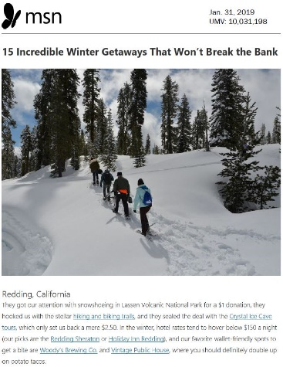
As for organic reach, the Redding CVB participated in a social campaign effort with U.S. Travel on National #PlanForVacation Day on Jan. 29. The 12 posts featured Lake Shasta Caverns, waterfalls, VisitRedding.com blog articles on family travel, bucket list attractions in Redding, and outdoor experiences. The posts generated 24,606 impressions and 1,149 engagements.
- The Redding CVB’s media outreach efforts secured two article placements in January about winter activities in the region. The article “15 Incredible Winter Getaways That Won’t Break The Bank” was picked up by Men’s Journal and MSN.com (see right) for a reach of 13.5 million unique monthly visitors. This was a result of pitching freelancer Perri Blumberg throughout the year since meeting with her in-person for a deskside meeting in January 2018. The article highlighted snowshoeing in Lassen Volcanic National Park, hiking and biking trails, Crystal Ice Cave Tours, Sheraton Redding and Holiday Inn, Woody’s Brewing Company and the revamped Vintage Public House. View the articles here:
- Men’s Journal: https://bit.ly/2G36uvv
- MSN.com: https://bit.ly/2S4N28a
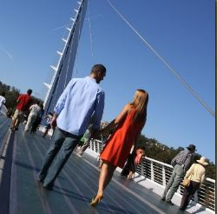
- Two new articles were posted to the VisitRedding.com blog to give the Redding CVB the ability to control the messaging and create interest for potential visitors to vacation in our destination. The two articles below have a wide demographic reach for outdoor activities:
- How to Plan a Perfect Couples Getaway in Redding – Promoting a relaxing getaway for two (breweries, wineries and fine dining), adventure for two (waterfalls, national and state parks, Sacramento River National Recreation Trail), and kid-friendly trip (Turtle Bay Exploration Park, Shasta Lake, Lake Shasta Caverns, Waterworks Park). Read here: https://bit.ly/2DOW4xi
- The 11 Best Hikes in Northern California – The trails picked were carefully selected to speak to a wide range of varying distances, difficulty levels, vantage points for scenic lookouts and location. A description of each trail included distance from downtown Redding and why that trail is special for hiking. Read here: https://bit.ly/2MJAcWL
International:
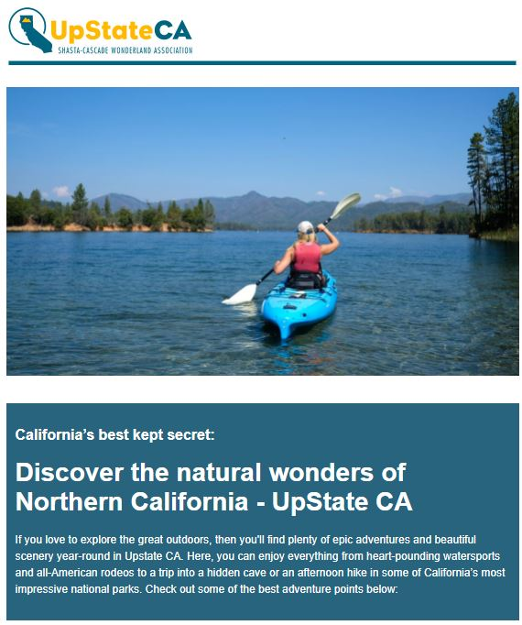
- A six-month Scandinavian campaign just finished in January. The Redding CVB and SCWA in partnership with the Visit California office in Scandinavia targeted the campaign at those who have the influence to sell Redding to potential visitors. Redding was promoted in three newsletters sent to 7,000 travel trade professionals, 4,000 media contacts as well as digital bloggers and influencers in Denmark, Sweden, Norway and Finland. The newsletters were distributed in September 2018, November 2018, and January 2019, which is the planning season for the travel trade to prepare to sell during the peak travel season. The open rate was 17.6, 18.75 and 18.2 percent, respectively. Visit California considered the open rate to be very good with an average open rate of 18.18 percent. As follow up, the RCVB and SCWA are partnering with North Coast in face-to-face meetings with travel trade and media at a U.S. Travel Show in Copenhagen, Denmark in March 2019 to further market Redding as a travel destination for Scandinavian travelers to explore.
- Newsletter 1: Discover California’s best kept secret (see above right)
- Newsletter 2: Active vacation in Northern California's scenic nature - Shasta Cascade
- Newsletter 3: California's secret outdoor paradise – UpState CA
Conferences/Meetings/Conventions/Trade Shows Attended:
- San Diego Travel & Adventure Show; Jan. 19-20, San Diego, CA; T.J. Holmes
Shasta County Film Commission Sports Commission & Local Event Coordinator:
Generating new group business for sports, local festivals, and/or film activity:
- Film Shasta hosted four crews that filmed in 10 different permitting jurisdictions for a total of 13 shoot days with 38 crew members and 112 room nights. Twenty local hires were part of these projects. In addition, we had four scouts in our area; responded to five permit requests for upcoming projects; submitted ad for Location California 2019 guide (see right); and added two new vendors on FilmShasta.com. The following projects which had Film Shasta support were released this month:
- Gold Rush episode 1/21/19: https://www.dailymotion.com/video/x70nzqd;
- Wild West Bass Trail 1/22/19: https://www.wildwestbasstrail.com/shastaproam-19/;
- Stronger than Carr Trailer 1/31/19: World premier is March 4 at the Civic: https://bit.ly/2TqMvtV
- In partnership with Bridge Bay Resort, the Redding CVB hosted the Wild West Bass Trail Tournament once again. This year was the first year the tournament sold out and the Pro-Am had 50 more registrations than last year. Continued followed up occurred with: American Junior Golf Association, BassMaster Tournament; Fireball Run, Fishers of Men, FLW, Flag Football World Championship, GWN Dragonboats, Great Inflatable Race, International Slow Pitch Softball Tournament; NASCAR, NSA-BPA Conference, NorCal Mountain Biking, North American Youth Sports, Powerboat Nationals, Pro-Watercross, Quick 6 Football Tournament, Santa Hustle, SCRIPPS, USA Softball, Spartan Race; and the following local events: Firereel Film Festival, Maker Faire 2020; Shasta Mud Run, Never Forgotten Games, Sundial Bridge Comic Con.
The Redding CVB submitted ad for SportsStars Magazine featuring the California Soccer Park and upcoming Quick 6 Football Tournament. The Redding CVB was featured in the Sports Events annual guide, Sports Planning Guide’s annual guide and California guide; and was the featured destination in Sports Destination Managements January e-newsletter; and site visit has been scheduled for Quick 6 tournament directors in advance of the March event.

*As part of our affiliation with California Film Commission and Film Liaisons in California Statewide (FLICS), and as a standard of good Film Office procedure, we are commonly obligated to conform to privacy laws and to keep filming information provided by filmmakers, producers, and location managers private. The relationship of trust built with filming organizations encourages an open dialogue which allows us to be more capable of offering services to them, enticing them to bring their projects to us.
Industry Relations & Group Coordinator:
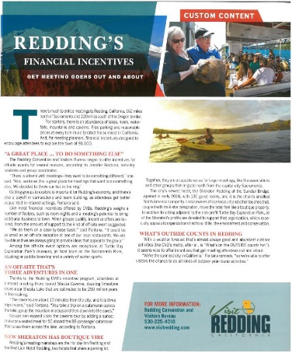
Generating new group business for meetings and conventions:
- The Redding CVB cultivated relationships to generate earned editorial content for an ‘Open for Business’ campaign to showcase Redding’s incentives and attractions to tour operators and meeting planners following the wildfires. Redding received a full-page placement in Small Market Meetings January 2019 edition (see right) with four photos. Student & Youth Travel Association included Redding in an e-newsletter with Redding in the subject line as ‘California’s Best-Kept Secret’ linked to an article on its website. Fire Starter Brands, a travel trade marketing firm, featured Redding as a destination in a newsletter that was sent out to 4,022 people with a 17.9 percent open rate, and sent out 700 one-page flyers to tour operators for the campaign. Leisure Group Travel published an article in the December 2018 issue promoting Redding’s complimentary site visits following the wildfires. The combined reach of these articles and newsletters is more than 47,000.
- SYTA: https://bit.ly/2t2ivsN
- Small Market Meetings: https://bit.ly/2CP2daZ
- Leisure Group Travel: https://bit.ly/2BjYfHF
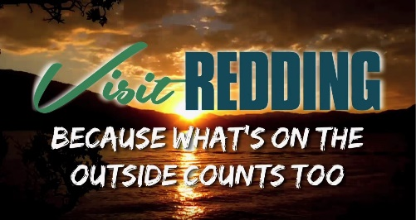
- In an effort to provide multiple assets as part of the “What’s on the OUTSIDE Counts Too” meeting campaign, the Redding CVB chose to do a targeted social media campaign on YouTube to meeting planners. The campaign ran across November-January on YouTube and generated 8,312 views, 4,155 minutes watched with a 97 percent average video completion rate. Watch the video here: https://bit.ly/2DHJfVo.
Groups, Conventions, Sports and Festivals:
In Proposal:
- The Redding CVB is actively working on eight different proposals to bring meetings and sports events to Redding.
Upcoming:
- Quick 6: This lead was generated through one of our marketing partners. In partnership with the California Soccer Park, a regional tournament is scheduled for March 24, 2019.
- BASS Nationals Fishing Tournament: May 7-11, 2019; Shasta Lake anticipating 300 room nights.
- Shasta Mud Run: May 11, 2019; expected attendance of 2,000 people.
- Sports Leisure Vacations: June 3-5, 2019; Sheraton Hotel at the Sundial Bridge.
- USA Softball 2019 National Championships for girls U14; U16 & U18 B divisions for softball. Tentative dates for this tournament are scheduled for July 23-28, 2019 – potential of 1,900 room nights.
- International Slow Pitch Softball (ISPS): A proposal was accepted for Big League Dreams to host the NorCal Championship Sept. 13-15, 2019. This three-day event will yield approximately 600 room nights and has the potential to become an annual event.
- Annual Rotary District Conference: May 2020 – approximately 400 attendees. *
- California Nevada Hawaii State Association Emblem Club (CNHSAEC) Annual Convention: May 1-4, 2020; Holiday Inn – estimated 500 room nights.
- The Western Section of the Wildlife Society Annual Meeting: Feb. 3-7, 2020; Red Lion & Holiday Inn – expected attendance of 500 people and 1,000 total room nights.
- Shasta County Mini Maker Faire: Fall 2020; expected attendance 2,000 people.
Recent:
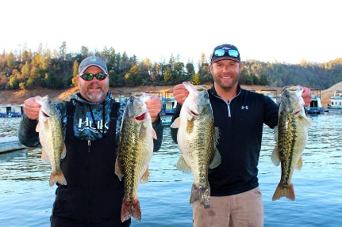
- Redding Marathon; Jan. 19, 2019; The Redding Marathon had 158 entrants in the 26.2-mile marathon, 86 in the Sundial 5K Race, and 180 participants in the Marathon Relay Team event. The Redding CVB promotion was through targeted ads on Facebook and Instagram in drive markets of the Bay Area and Sacramento, generating 89,232 impressions and 580 clicks to the registration website.
- Wild West Bass Tournament: Jan. 25-27, 2019; The 2019 Wild West Bass Trail (WWBT) concluded their weigh-in of the season-opener Pro/Am at the SuperClean Showdown on Lake Shasta with Alex Niapas of Angels Camp, Calif. weighing in the largest five-fish limit of a WWBT event on the Northern California fishery. Shasta Lake detailed report to follow.
* Denotes a joint effort of Redding Convention and Visitors Bureau and lodging facilities with client communication.
Winners: Jason Remmers & Alex Niapas

