COMMUNITY SERVICES ADVISORY COMMISSION REPORT
Redding Convention & Visitors Bureau (RCVB)
December 2018

Tracking Transient Occupancy Tax (TOT)
TOT revenue reported in December for the City of Redding and collected from Redding lodging properties was $675,943.41, which is an 83.3 percent increase over December of 2017. Overall, this is a fiscal year-to-date TOT increase of 26.3 percent.
Turtle Bay Numbers
Turtle Bay Visitor Desk – year-to-year comparison for Visitor Statistics:
 | December – 2017 |  | December – 2018
Directions | 24 |  | 16
RV Info | 4 |  | 1
Hotel Info | 2 |  | 3
Marina/Camping | 7 |  | 1
Food | 32 |  | 23
Shopping | 34 |  | 10
Activities/Maps | 227 |  | 246
Total Visitor Requests | 330 |  | 300

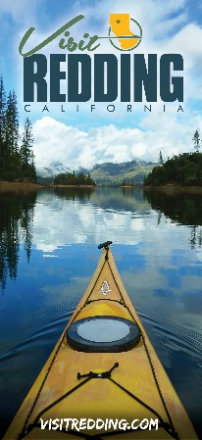
Marketing and Advertising:
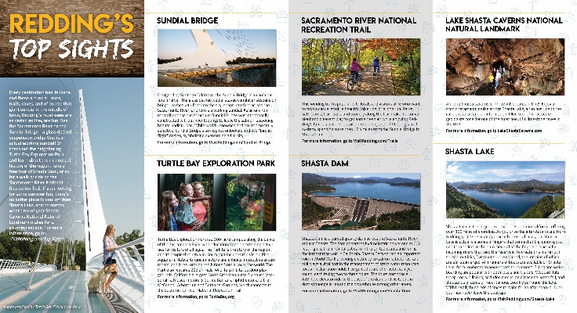
- The Redding CVB completed the first draft for a redesign of the Redding Visitors Guide. The new design focuses on providing more imagery of the area to show off Redding’s natural beauty and bring the visitor guide in line with current branding guidelines. The Redding CVB is currently in the process of proofreading and putting the final touches on the guide, with plans for release of the final version in the spring of 2019.
- The Groups section of the Visit Redding website was restructured to provide easier access to information and to highlight new marketing pieces. Meetings and tour buses were split out into separate categories and new marketing videos for both were placed on the pages to better highlight Redding as a group destination. Digital versions of meeting and tour bus brochures were also placed on the site for download alongside the site listings to ensure that the site provides easy access to any information a planner might need.
- New virtual tours of Lake Shasta Caverns National Natural Landmark, the Sundial Bridge, and Turtle Bay Exploration Park were added to the Visit Redding website as part of an ongoing effort to add more visual and interactive elements to the site. The tours allow users to click and drag to explore the attraction in a way that isn’t possible with traditional photos.
Public Relations:
- Media outreach continues to produce results, especially from travel writer Maya Stanton of Budget Travel, whom the Redding CVB hosted for a trip in May. The published articles in the table below reached 31.2 million unique monthly visitors (UMV) in December as a result of the Redding CVB’s relationship and ability to deliver content in a timely fashion with the writers. Budget Travel has now included Redding and Shasta-Cascade in six articles since Stanton’s visit, maximizing the ROI for her visit. The top attractions mentioned in the articles include the Sundial Bridge, tasting and touring at Lucero Olive Oil, Lassen Volcanic National Park, Lava Beds National Monument and the Siskiyou Ice Rink.
Publication | Article | Reach (UMV)
LA Times | These world-class bridges are Insta-ready | 23.9 M
LA Times | These world-class bridges are Insta-ready (print) | 555 K
Budget Travel | 9 California Food & Beverage Makers to Visit in 2019 | 1.47 M
Budget Travel | 6 Great Places for Cool Winter Fun | 1.47 M
Matador Network | Best American Rinks to Skate at This Christmas – That Aren’t in New York | 3.81 M
TOTAL |  | 31.2 M UMV

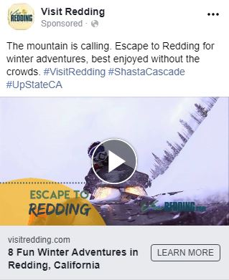
- A Visit Redding winter campaign was centered around escaping to Redding for a winter adventure. It kicked off with a blog about 8 Fun Winter Activities for the Whole Family in Redding, CA where it featured skiing at Mt. Shasta, exploring winter at Lassen Volcanic National Park, sledding at Eskimo Hill, skating at the Siskiyou Ice Rink, touring Lake Shasta Caverns, activities at Castle Crags and Burney Falls. The blog was promoted on social channels, receiving a 2.5 percent click-through-rate (CTR) on 18,038 impressions. The winter blog was also promoted by using the Visit Redding winter commercial on social media where it received 23,446 impressions, 7,766 engagements for a cost per engagement of $0.01. The winter commercial can be viewed here: https://bit.ly/2TekDZd. This was the first of many campaigns planned to combat the negative media wildfire coverage.
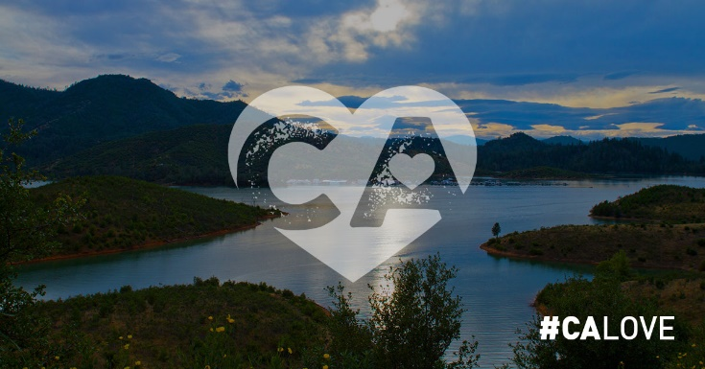
- Promotion of Redding as a premier vacation destination on social media is crucial following the wildfires. The Redding CVB partnered with Visit California for its “The Power of Love” campaign, joining politicians and celebrities to encourage people to donate to Red Cross for victims of the wildfires in California by sharing social posts with #CALove. Other social media promotion included a paid campaign that included carousel ads on Facebook and Instagram featuring activities such as winter adventure, hiking, biking, national and state parks, Turtle Bay Exploration Park, Lake Shasta Caverns, breweries, and waterfalls. The campaign has reached 153,735 people since Nov. 28.
International:
- The Redding CVB partnered with Shasta-Cascade Wonderland Association (SCWA) in a three-month digital campaign with the Epoch Times targeting Chinese travelers via Chinese websites, Facebook, and Chinese social media. The total cost of the campaign was $7,650 which resulted in 4.97 million impressions ($0.0015 per impression), 5,000-plus clicks to the Redding/Shasta Cascade Chinese language travel information page ($1.53 per click), with 70 people requesting destination information. In follow up, destination information was emailed and hardcopies were mailed as requested.
Conferences/Meetings/Conventions/Trade Shows Attended:
- California Society of Association Executives Seasonal Spectacular, December 12-13; Sacramento, CA; Jennifer Fontana & Laurie Baker
- California On Location Awards, December 16; Beverly Hills; Sabrina Jurisich
- Film Liaisons in California Statewide Board Meeting, December 17; Los Angeles; Sabrina Jurisich
Shasta County Film Commission Sports Commission & Local Event Coordinator:
Generating new group business for sports, local festivals, and/or film activity:
- The Film Commissioner co-chaired and attended the 24th annual California On Location Award show (COLA), which hosted more than 600 location managers and industry professionals and recognizes California-based productions. Four categories received nominations in Shasta County with three making it to the finalist round in Reality Television (BBC’s “Top Gear”), Commercials (Nature Valley), and Public Employees (Lassen Volcanic National Park). “Top Gear” and Shasta County was featured on the cover and on a six-page spread in the official COLA magazine which every guest in attendance received. A site visit was hosted in December for a production looking at shooting a full-length feature film in 2019. We also hosted two crews that filmed during the month for a total of four shoot days with 22 crew members and 46 room nights. In addition, Film Shasta responded to three permit requests for upcoming projects and coordinated a meeting with local producers to continue conversations on developing local resources.

- Follow up continues with upcoming events and those in proposal including Powerboat Nationals; Redding Marathon; Wild West Bass Trail; Quick 6 Football Tournament; Shasta Mud Run; BassMaster Tournament; Jr. Prep Sports; USA Softball; International Slow Pitch Softball Tournament; and North American Youth Sports.
*As an affiliation with California Film Commission and Film Liaisons in California Statewide (FLICS), and as a standard of good Film Office procedure, we are commonly obligated to conform to privacy laws and to keep filming information provided by filmmakers, producers, and location managers private. The relationship of trust built with filming organizations encourages an open dialogue which allows us to be more capable of offering services to them, enticing them to bring their projects to us.
Industry Relations & Group Coordinator:
Generating new group business for meetings and conventions:
- The Redding CVB partnered with Red Lion, Holiday Inn and Sheraton Hotel Redding in attending the 2018 California Society of Association Executives Seasonal Spectacular Tradeshow in Sacramento. Attendees of the event were association meeting planners there to connect with destinations and properties with the space to accommodate meetings and conferences. Of the estimated 1,000 attendees, 90 stopped by our booth. For added exposure and to drive more attendees to the booth, the Redding CVB sponsored the luncheon wristband, which included our logo and booth number. The Redding CVB conducted eight one-on-one appointments where two RFP’s were received. Properties will continue the follow-up with interested meeting planners to invite them to come for site visits.
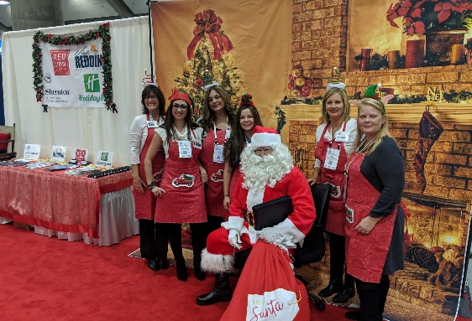
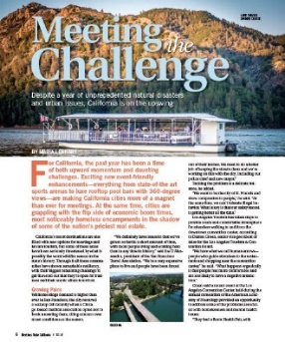
Due to the strong partnership the Redding CVB has with vendors, many were willing to help with an after the fires campaign that the office is calling the “Skies are Clear” campaign. As part of the Redding CVB ‘skies are clear’ plan, many articles, editorials, and newsletters highlighting Redding were featured in various publications. One of these is Meetings Today, with a print circulation of 55,000 which featured Redding as a meeting destination.
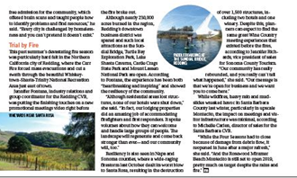
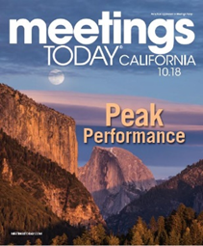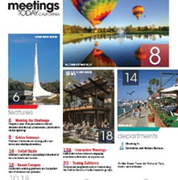

Groups, Conventions, Sports and Festivals:
In Proposal:
- California Association of Resource Conservation District: November 2019, 400 room nights.
- Annual Rotary District Conference: May 2020, for approximately 400 attendees.*
- California Trails Conference: 2020, for an estimated 445 room nights.
- Amateur Sports Alliance of North America: Big League Dreams and the California Soccer Park are being considered for this event, which anticipates between 500 and 750 room nights.
- American Junior Golf Association: Riverview Golf & Country Club is being considered for its Junior Golf Tournament in 2019.
- Fishing League Worldwide (FLW): Shasta Lake is being considered for the 2020 annual tournament. This three-day event has an average of 356 anglers. FLW was last in Redding in 2016 and the event rotates between various locations.
- Fishers of Men: Legacy Series Championships fishing tournament in 2019. There is also the possibility of its 2019 Team Series National Championship at Shasta Lake depending on if the Redding CVB can find a local coordinator. These are multi-day events that average between 147 and 460 room nights.
- Fundracer Events: Great Inflatable Race. The event organizer is submitting an application for use of Enterprise Park in spring of 2019.
- Jr. Prep Sports CA: This lead generated through one of our marketing partners, a proposal has been submitted in partnership with California Soccer Park for a regional tournament in spring of 2019.
- NorCal High School Cycling League**: Mountain Biking Race in 2019. Due to the Carr Fire the event organizer is now considering Mt. Shasta Ski Park in lieu of Whiskeytown National Recreation Area for this event.
- National Flag Football: This lead was generated through National Association of Sports Commissions (NASC). A proposal has been submitted in partnership with California Soccer Park for a 2019 event.
- Tough Mudder: Nash Ranch is being considered for this event, which has the potential to bring 1,500 to 2,500 room nights.
- USA Cycling: Mt. Shasta Ski Park is being considered for a 2019 event, anticipating at least 5,000 room nights.
Upcoming:
- Wild West Bass Tournament: Jan. 11-13, 2019 & Feb. 17-18, 2019; Shasta Lake – anticipating 300 room nights.
- Quick 6: This lead was generated through one of our marketing partners. In partnership with the California Soccer Park, a regional tournament is scheduled for March 24, 2019.
- BASS Nationals Fishing Tournament: May 7-11, 2019; Shasta Lake anticipating 300 room nights.
- Sports Leisure Vacations: June 3-5, 2019; Sheraton Hotel at the Sundial Bridge.
- USA Softball 2019 National Championships for girls U14; U16 & U18 B divisions for softball. Tentative dates for this tournament are scheduled for July 23-28, 2019 – potential of 1,900 room nights.
- International Slow Pitch Softball (ISPS): A proposal was accepted for Big League Dreams to host the NorCal Championship Sept. 13-15, 2019. This three-day event will yield approximately 600 room nights and has the potential to become an annual event.
- Annual Rotary District Conference: May 2020 – approximately 400 attendees.*
- California Nevada Hawaii State Association Emblem Club (CNHSAEC) Annual Convention: May 1-4, 2020; Holiday Inn – estimated 500 room nights.
- The Western Section of the Wildlife Society Annual Meeting: Feb. 3-7, 2020; Red Lion & Holiday Inn – expected attendance of 500 people and 1,000 total room nights.
* Denotes a joint effort of Redding Convention and Visitors Bureau and lodging facilities with client communication.

