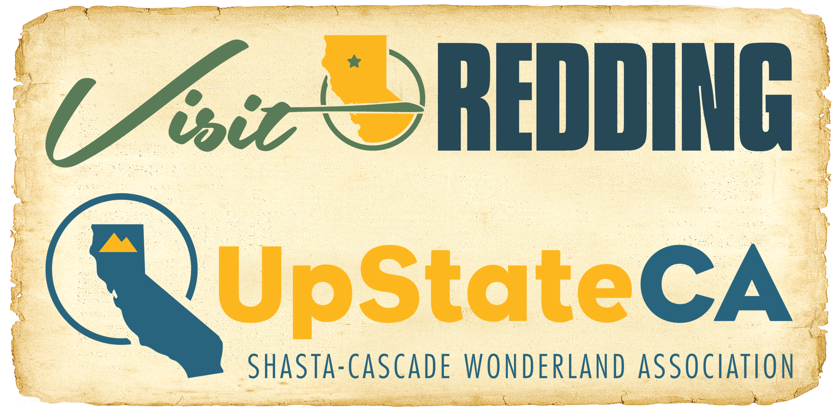

For Immediate Release

MEDIA ALERT #2:

RESOURCES FOR CARR WILDFIRE INFORMATION

UPSTATE CA STRENGTHENING WITH COMMUNITY SUPPORT

REDDING, Calif. (July 27, 2018) – The Shasta County area is currently experiencing wildfire conditions and a local/state emergency has been declared. The Redding Convention & Visitors Bureau, the official tourism marketing organization for the City of Redding, and the Shasta-Cascade Wonderland Association (SCWA) continues to closely monitor the situation.

Laurie Baker, CEO for the Redding CVB and General Manager of the SCWA, notes the efforts of emergency services personnel and the community as a whole.

“We applaud the collective efforts of emergency services personnel and the hospitality community,’ Baker said. “The health and safety of our neighbors and visitors is our top concern and we’ve already seen many examples of the community pulling together to help each other remain strong.”

It is important to note that the Shasta Cascade region represents roughly 25 percent of the state’s land mass in an area roughly the size of Ireland. We recommend that those planning a visit over the next several days check with their accommodations providers and local authorities for the most updated status of the situation before their planned stay.

Visitors who are in the area may refer to this list of resources, which can provide additional information. News outlets are encouraged to contact these organizations directly for updates:

Cal Fire: Website | Facebook | Twitter
Shasta County Sheriff’s Office: Website
For fire info, call Shasta County Fire Department: 530-225-2510.

Evacuation Centers
- American Red Cross @ Shasta High School – 2500 Eureka Way, Redding, CA 96001
- Grace Baptist Church – 3782 Churn Creek Road / Redding, CA 96002
- Rolling Hills Casino (& Livestock) – 2655 Everett Freeman Way, Corning, CA 96021
- Weaverville Elementary School – 129 S. Main St., Weaverville, CA 96093
- CrossPointe Church – 2960 Hartnell Ave., Redding, CA 96002

For additional information on visiting Redding, please explore VisitRedding.com, and follow us on Facebook and Twitter @VisitReddingCA or Instagram at VisitRedding.

About Redding, CA
Situated at the northern end of the Sacramento River Valley, Redding is the hub city in Shasta Cascade and is located just two hours north of Sacramento and three hours northeast of San Francisco. Averaging 300+ days of beautiful weather a year, Redding offers outdoor adventure and attractions for every age, along with great wine, food, sporting and cultural events, dining, lodging and entertainment. The great Sacramento River runs through the center of town, helping earn Redding the fame of being America’s great kayaking destinations. Nearby scenic lakes, rivers, state and national parks, including Shasta Lake, Whiskeytown National Recreation Area and Lassen Volcanic National Park, make Redding a fantastic base-camp for exploration in Shasta Cascade, offering Any Adventure, Any Day. Redding is conveniently located at the crossroads of I-5 and California state routes 299 and 44, and is accessible by daily flights from San Francisco.

About Shasta Cascade
California’s hidden gem, the Shasta Cascade region offers 25 percent of the state’s land mass with just three percent of the overall population. Covering an area roughly the size of Ireland, the Shasta Cascade region is the perfect place to get enjoy the great outdoors. Comprised of eight rural counties historically known for being part of the pioneer gold rush in the mid-1800s, this majestic region of northern California is abundantly scattered with lakes, rivers, mountains and historic mining towns, and includes Lassen Volcanic National Park, two national monuments, six national forests and seven California state parks offering unforgettable fun and adventure. This area offers a wide variety of opportunities for outdoor recreation with magnificent landscapes that include towering volcanoes, alpine ranges, and glaciers, waterfalls, lush forests, pristine lakes, and roaring rivers. Shasta Cascade is easy to get to by auto, air, or Amtrak, and offers an off-the-beaten-path experience where people discover the abundance of nature in one of the few unspoiled areas remaining in California. For more information, visit www.shastacascade.com, like our Facebook page www.facebook.com/ShastaCascade, or find us on twitter www.twitter.com/ShastaCascade.

Media Contacts:

T.J. Holmes
Redding Convention & Visitors Bureau
TJ@VisitRedding.com
Office: 530.225.4105 / Cell: 530.513.1390

Terence Gallagher
Lou Hammond Group

terryg@louhammond.com
Office: 212-891-0211 / Cell: 917-539-0633

###

