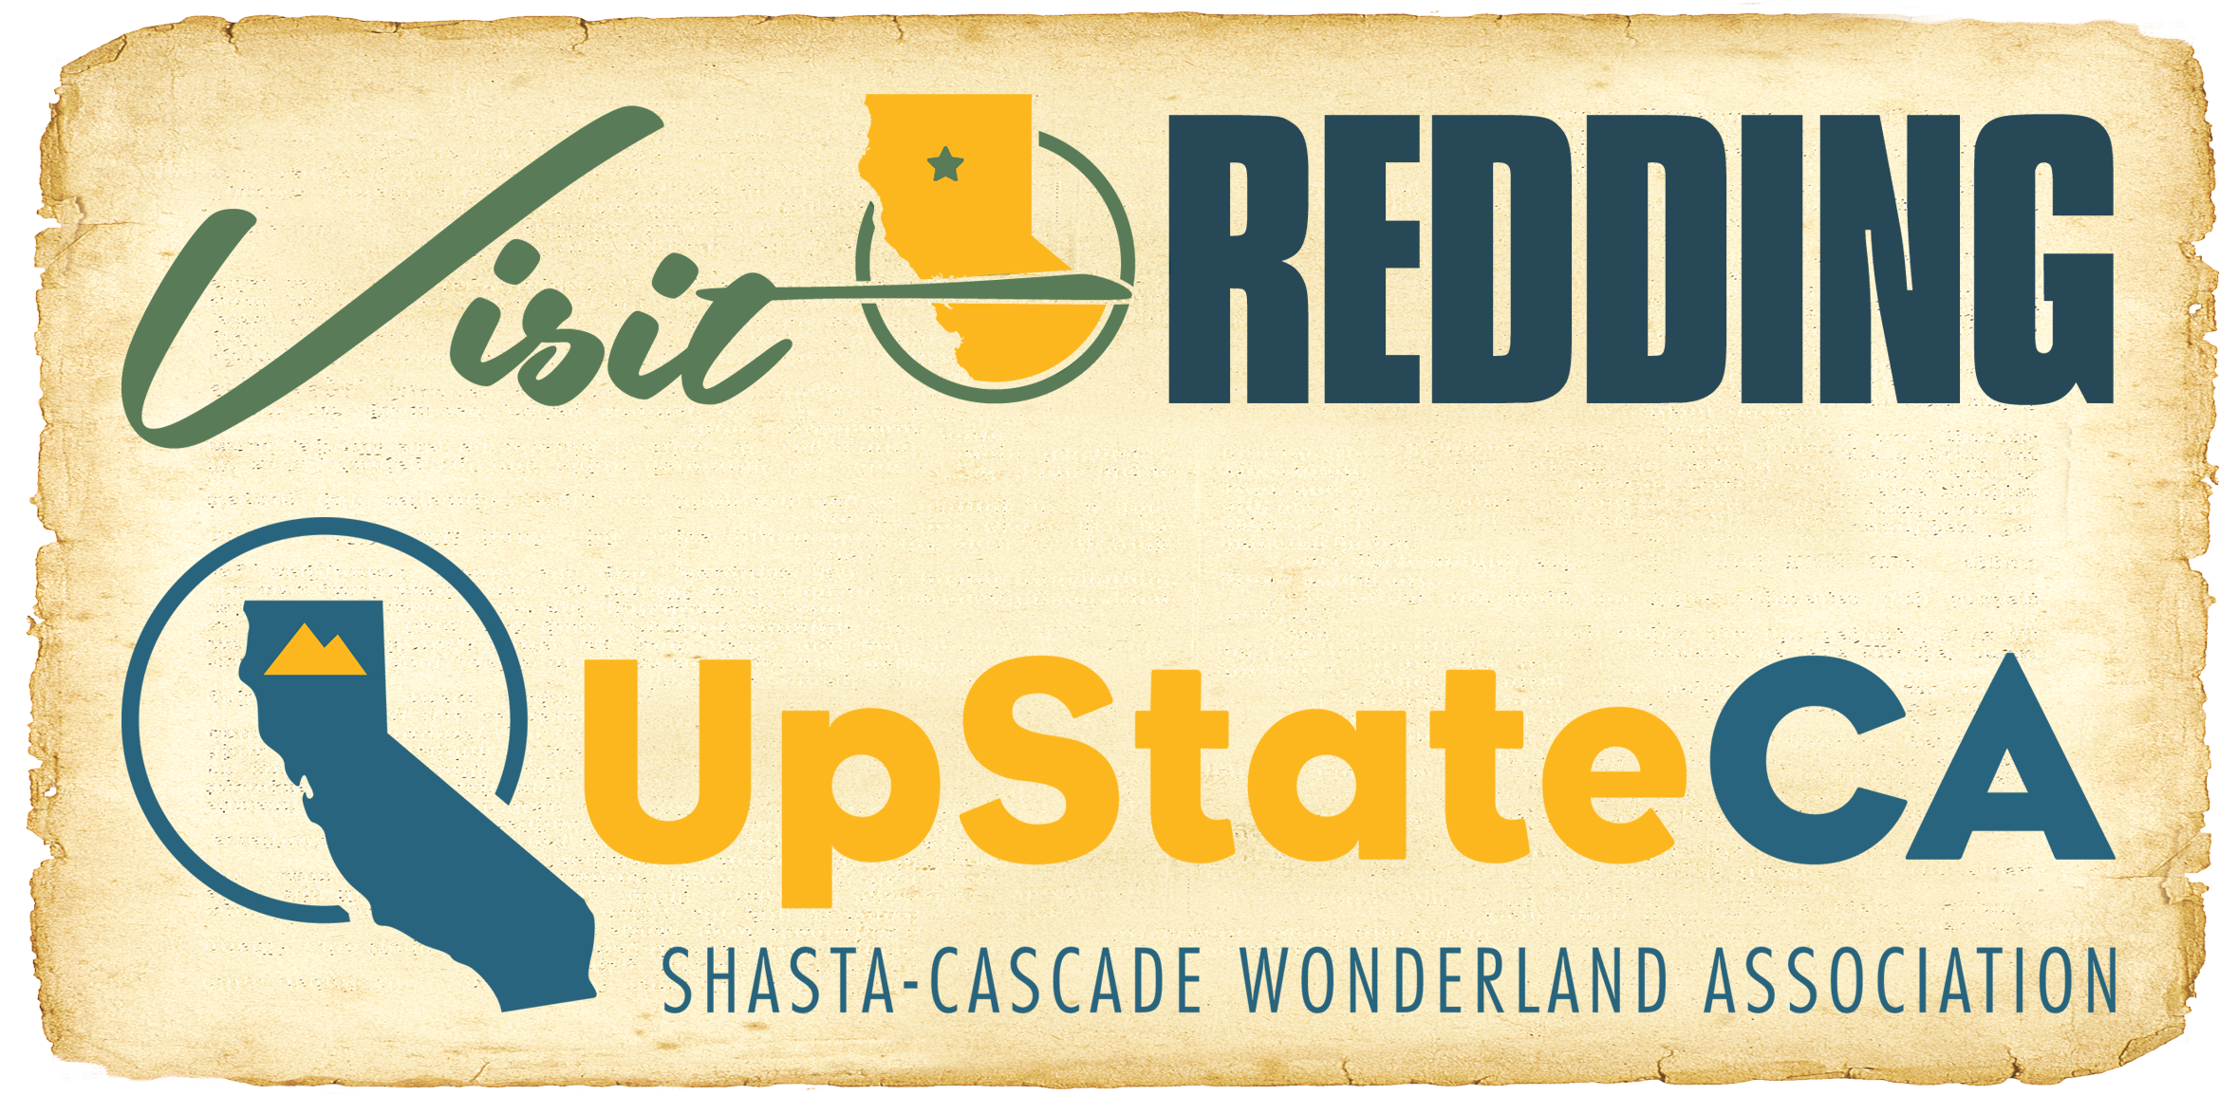

For Immediate Release

MEDIA ALERT #3:

CARR WILDFIRE INFORMATION

HOSPITALITY INDUSTRY SHOWING TRUE COLORS DURING CARR FIRE

REDDING, Calif. (July 28, 2018) – The Redding Convention & Visitors Bureau, the official tourism marketing organization for the City of Redding, and the Shasta-Cascade Wonderland Association (SCWA) applaud the efforts of emergency services personnel, members of the community, and the hospitality industry in the collective response to the Carr wildfire.

According to Laurie Baker, CEO for the Redding CVB and General Manager of the SCWA, the immediate response to the fires have been typical of the spirit of the close-knit Shasta County community.

“We are so appreciative of the incredible efforts of emergency services personnel and the hospitality community,” Baker said. “These efforts are indicative of the ‘Shasta County Strong’ spirit that has always been present here and we’ve already seen many examples of the community pulling together to help each other.”

Many area hotels have remained open while accommodating first responders and evacuees alike. Hotel and restaurant staffs have worked around the clock to support guests and others who may be visitors to the area or neighbors.

Those interested in determining if accommodations are available can go to www.visitredding.com/home/places-to-stay for a listing of hotels in the area.

Baker noted that the region has received an outpouring of well-wishes from all over the country and expressed the hope that when the time is right, those desiring to visit the area will return in full force to support local businesses.

“As our wonderful first responders continue to work diligently, we know our hospitality community will be there to help wherever possible as well as to welcome visitors when the time is right,” said Baker.

Those seeking more information on the current situation in Shasta County may refer to this list of resources. News outlets are encouraged to contact these organizations directly for updates:

Cal Fire: Website | Facebook | Twitter
Shasta County Sheriff’s Office: Website
For fire info, call Shasta County Fire Department: 530-225-2510.

Evacuation Centers
- American Red Cross @ Shasta College – 11555 Old Oregon Trail, Redding, CA 96003
- Grace Baptist Church – 3782 Churn Creek Road / Redding, CA 96002
- Rolling Hills Casino (& Livestock) – 2655 Everett Freeman Way, Corning, CA 96021
- Weaverville Elementary School – 129 S. Main St., Weaverville, CA 96093
- CrossPointe Church – 2960 Hartnell Ave., Redding, CA 96002
For additional information on visiting Redding, please explore VisitRedding.com, and follow us on Facebook and Twitter @VisitReddingCA or Instagram at VisitRedding.

Media Contacts:

T.J. Holmes
Redding Convention & Visitors Bureau
TJ@VisitRedding.com
Office: 530.225.4105 / Cell: 530.513.1390

Terence Gallagher
Lou Hammond Group

terryg@louhammond.com
Office: 212-891-0211 / Cell: 917-539-0633

###

