

RTMG Board of Directors
PO Box 491915
Redding, California, 96049

Notice of Special Meeting

Notice is hereby given that a special meeting of the Redding Tourism Marketing Group is hereby called by the undersigned to be held on April 14, 2026 at the Sheraton Redding Hotel at the Sundial Bridge to begin at 10:00 a.m. PDT

Business to be transacted at said meeting, and the only business to be transacted is as follows:

- See Attached Special Meeting Agenda

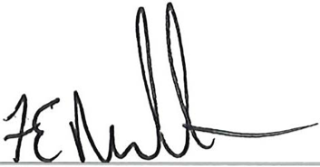

Ed Rullman, Chair of the Board

Date: April 13, 2026

